

**University of Engineering & Technology, Lahore (FSD Campus)**

2K19

**Variable DC Power Supply**

**Electric Circuits Project**

**2K19 Mechatronics & Control Engineering**

**2019-MC-255**

**2019-MC-277**

**2019-MC-281**

**2019-MC-263**

**Function:-**

As, we know this is a variable voltage DC Power supply from the title. So, in this supply voltage are changed by using a variable resistor (Rheostat). The AC supply is converted to DC and then regulated by voltage regulator IC’s. The supply contains two channels, the channel one is variable and voltage could be varied from 0-24V and could give a current of about 800m. And the channel number two could be called a fix channel. But we can also change the voltage in this channel using a selector switch have three output terminals. In this channel voltages are varied but there is a limitation. It could give 5V, 9V and 12V using three positioned switch. So, we can say basically there are two circuits in the supply. Now, moving towards details the function of each component used in circuit is shown below:-

1. **Transformer:-**

“An electric device used to transform (step-up or step-down) voltage using electromagnetic induction.”

It is an electromagnetic device which can increase or decrease AC voltages. Here we will use a step own transformer and it converts 220 voltage to 12 voltage. But in this case it could give 24 voltages from its two secondary coils. We are using a tapped two secondary coil transformer. It could give a current of 2A. Basically we want 24V at the output so, we converted the voltages to 24V and in second circuit we want 12V maximum so, we use 12V coil.

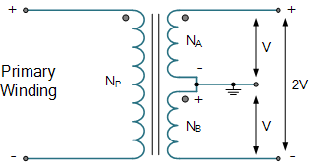

As, shown in diagram the primary winding or primary coil is magnetically connected with two secondary coils and E.M.F is induced in both depending upon turn ratios. Transformer transformed the voltages and we have our desired D.C voltages

1. **Diodes (Rectifier):-**

“Diodes are basically p-n junction semi conductor device, they are unidirectional electric conductors and current flows in only one direction.”

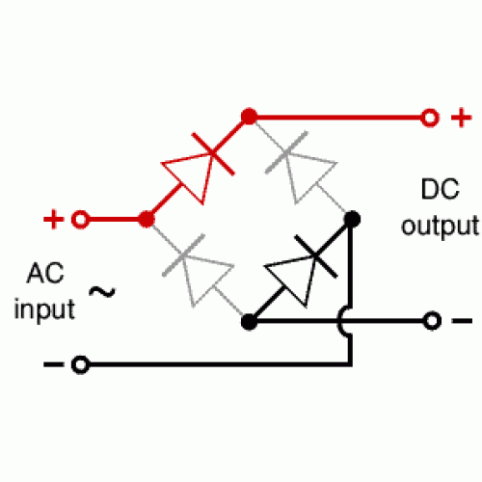Here we have 24V AC but we need DC for the power supply so for that diodes are used. Diodes are semi conductors and current can flow only when it is connected in forward bias and it behaves as a high resistance when in reverse bias. Now, here we used it as a rectifier. Rectifier converts AC wave form to DC and l we need DC for the supply. Actually the works in a simple way the let the positive waveform to flow and then stops the negative one but due to the bridge negative waveform also flows from other two diodes used in a bridge. A full wave rectifier is shown in figure with input output waveforms:-

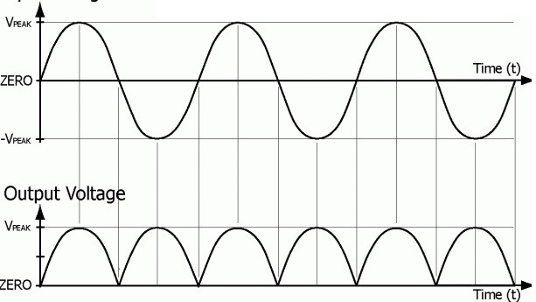

Here AC wave from is converted to DC and it is not alternating from positive to negative or vice versa which is our requirement.

1. **Capacitors (Polarized):-**

Till we have transformed the AC and rectified it to DC. Now we have a DC wave form but it also changing not from positive to negative but from maximum to zero. So for that we will use filter capacitors

“Capacitor is a device used to store electric energy in the form of electric field”

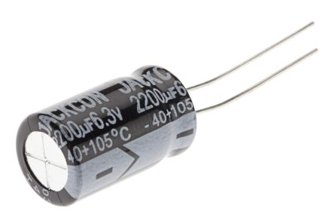So, the capacitor charges and provides a constant wave form of voltages because it didn’t let the voltage to change on it abruptly. Capacitor stores the energy in its field and we use its stored energy. For example let a water pump gives a little amount of water in a time so, we can use a storage tank so water could be supplied continuously. Hence we can say capacitor is an energy storing tank and stores the energy and provides us constantly. But why polarized and what is polarized capacitor? So answer is that we are dealing with DC and DC has a positive or negative and polar capacitors also have a fixed polarity so, due to the fixing of negative and positive charge we use this capacitor in our circuit. A polarized radial capacitor as used by us is shown:-

Here we can see that it has a negative sign on it which indicates the negative terminal of capacitor. The wave form of filtered DC is shown in figure:-

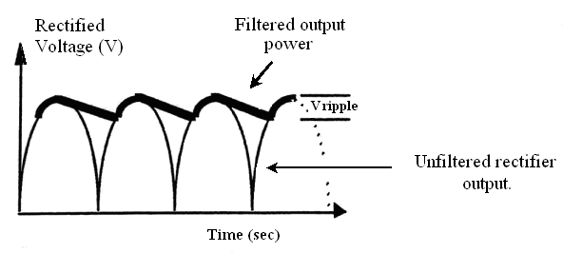

1. **Capacitors (Non-Polar):-**

A simple capacitor has no poles and any fixed polarity. We have a filtered output then why we are using the non-polar one? Most of the times the required capacity is in order of 1uF-100uF and such values can only be practically achieved with electrolytic capacitors (the one you quite correctly call “polarized”). However, this kind of capacitors has rather large equivalent series resistance, which means they cannot cope with fast transients. Therefore they are connected (in parallel) with other type of caps, such as ceramic, most often 10nF-100nF, in order to improve fast transient response (block high frequencies). The non polar capacitors are shown in figure:-

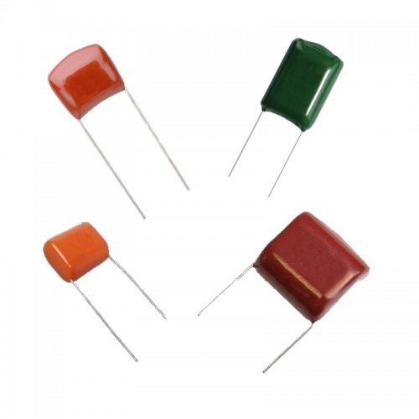

1. **Adjustable Voltage Regulator (LM317T):-**

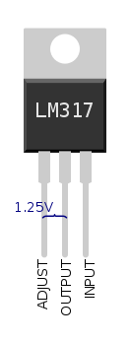“LM317T is basically an IC and is also known as adjustable voltage regulator. It regulates DC voltages by switching and the programming given to it during manufacturing.”

It is shown in figure,

It has three terminals named as 1, 2 and 3. Terminal 1 is adjustment, 2 is output and 3 is input. It can change DC voltages from 1.25-37V maximum and input should be 3-40V. in our case we are giving it 24V DC so, it regulates the voltage from 1.25-24V. It is worked by biasing its output and adjustment terminals using resistors. Its reference voltages are 1.25 and these are the voltage between its output and adjustment terminals. We connected it with a heat sink in our circuit because it could accurately work in 40oC so, in summers it could have an error in regulation without a heat sink. It use p-n or n-p junction for switching and changes the output voltage.

1. **Fix Voltage Regulator (LM78xx):-**

These are also voltage regulator and provide a fixed voltage at their output. Basically LM78xx is not its name. It is only recognition code the names could be LM7805, LM7806 and LM7809 and so on. Its last two letters represents its output voltages as 7805 could provide 5 voltages and 7809 could 9 voltages thus LM7824 could provide 24 voltages. These are also semi conductor ICs. They also have three terminals named as 1, 2 and 3. Terminal 1 is input, 2 is ground and 3 is output. We have to give it voltages using their data sheets. We are using t=7805, 09 and 12 regulator for our fixed supply. Now by using them they will provide us our required voltages 5, 9 and 12.

1. **Diodes (Feed-Back):-**

These are simple diodes as used in the rectifier, these are 1N4007 diodes. They are used with the ICs so, they can‘t let the ICs to become reverse bias. They don’t let the current to flow from input to positive terminal directly. The basically protect an IC from external voltages somehow applied on output terminal. They are connected in reverse bias with the IC. If the load is inductive, there are times when the IC must be on, but current flows in the opposite direction. The diode gives this current a path to flow. If the diode is not used, the inductive current ceases instantly, generating high voltage peaks.

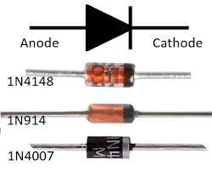

1. **Resistors:-**

These are used in biasing of the IC resistor is biased with the adjustment and output terminal of IC. Now we know that there are 1.25V between adjustment and output terminal of IC. So, there will be 1.25V on the resistor. This resistor is used because if variable is set to zero then there could be a load between output and adjustment terminal. But this resistor is only used with LM317T not with LM78xx. The variable resistor is used to change the resistor to change the output voltage at LM317T and we can see in formula in calculations the voltages are changes when resistance is changed. The variable resistors we are using is potentiometer and by short circuit its two terminals it becomes a variable resistor.

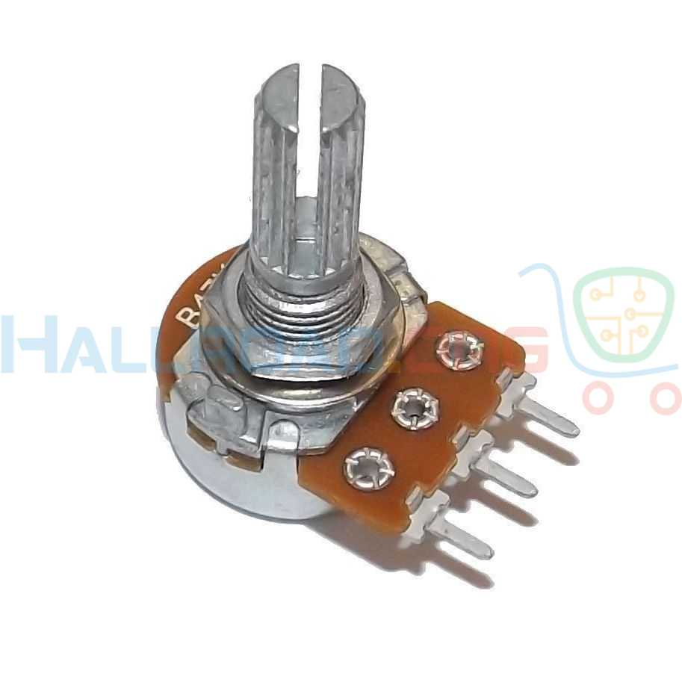

1. **Selector Switch (Three Positioned):-**

Here we are using selector switch. The selector switch is basically single pole three through switch. And have an input and three output terminals. It is used to select the output voltages at the fixed power supply

**Circuit Diagram:-**